COMMON COURSE ASSIGNMENT FORMAT
ASSIGNMENT PROBLEM / CHALLENGE: E-Commerce Data Warehouse and Customer Churn Prediction

A. Assignment Information
Department | CSE
Programme | Regular
Course Code & Course Name | CSA1613 – Data Warehousing and Data Mining
Academic Year / Batch | 2024
Faculty Name | Dr. K.V. Kanimozhi
Assignment Title | Design and Development of an Integrated Data Warehouse and Data Mining System for E-Commerce Data Warehouse and Customer Churn Prediction
Date of Issue | 31/08/2026
Date of Submission | 02/09/2026
Maximum Marks | 100
Course Outcome(s) – CO | CO1: Design suitable data warehouse architectures and dimensional models that support effective decision-making.  CO2: Apply data preprocessing methods such as cleaning, integration, transformation and reduction to prepare reliable data.  CO3: Assess classification techniques on practical data to predict outcomes accurately and support informed decisions.
Bloom's Taxonomy Level | L3 – Apply; L4 – Analyze; L5 – Evaluate; L6 – Create
SDG Mapping | SDG 8 – Decent Work and Economic Growth; SDG 9 – Industry, Innovation and Infrastructure; SDG 12 – Responsible Consumption and Production
Industry / Societal Relevance | An integrated e-commerce data warehouse can help organizations understand customer purchasing patterns, recognize valuable customers and make better customer-retention decisions.

B. Assignment Problem / Challenge
E-commerce businesses generate large amounts of information from customer accounts, orders, products, payments, deliveries and online interactions. These records are often stored in different operational systems and may use different formats, names, structures and levels of detail. Because of this, management needs a centralized analytical environment that can combine the information and turn it into useful business knowledge.
The organization needs to study customer purchasing behavior, measure product and regional performance, identify valuable customers, group customers into meaningful segments, understand seasonal sales trends and predict which customers may stop purchasing. Customer churn represents a reduction in customer engagement or a complete stop in purchasing activity. Early identification of churn can help the organization take suitable retention actions.
The assignment therefore requires students to design, implement, analyze and evaluate an integrated Data Warehousing and Data Mining solution. The solution should combine ETL processing, dimensional modeling, OLAP analysis, data preprocessing and classification models such as Decision Tree, Naïve Bayes and Support Vector Machine.

C. Problem Statement
The main objective is to design and develop an integrated E-Commerce Data Warehouse and Customer Churn Prediction system. The system should combine customer, order, product, payment, delivery and website-interaction information into a centralized analytical warehouse. A suitable Star Schema or Snowflake Schema must be created, followed by a complete ETL process for extracting, transforming, cleaning, integrating, validating and loading the data.
The project must also demonstrate the major OLAP operations—Roll-up, Drill-down, Slice, Dice and Pivot—and use them to study business performance. In addition, Decision Tree, Naïve Bayes and SVM models must be developed to predict customer churn and compared using suitable evaluation measures. The final solution should provide useful business recommendations while protecting customer privacy, promoting fairness and supporting responsible use of data.

D. Requirements and Constraints
- Identify the operational data sources and clearly describe their entities, attributes and relationships.
- Combine customer, order, product, payment, delivery and interaction data through common identifiers and clearly documented matching rules.
- Create and justify a Star Schema or Snowflake Schema by defining fact tables, dimension tables, keys, measures and hierarchies.
- Develop a repeatable ETL workflow covering extraction, transformation, cleaning, integration, validation, loading and process logging.
- Prepare the data by handling missing values, duplicates, inconsistent records, outliers, transformations, reduction and discretization where necessary.
- Perform Roll-up, Drill-down, Slice, Dice and Pivot operations and explain the business meaning of each result.
- Analyze high-selling products, customer segments, seasonal trends, regional performance and high-value customers.
- Develop and compare Decision Tree, Naïve Bayes and SVM models for customer churn prediction.
- Evaluate the models using Confusion Matrix, Accuracy, Precision, Recall, F1-score and Cross-validation.
- Suggest customer-retention strategies based on the analytical and prediction results.
- Address privacy, fairness, transparency, possible bias, consent and responsible use of customer information.
- Clearly record assumptions, limitations, reproducibility requirements and computational constraints.

E. Student Work

1. Problem Understanding and Formulation
Students should clearly explain the e-commerce business problem and describe why an integrated analytical data warehouse is required. The expected results should include multidimensional OLAP analysis, customer-related insights and a churn prediction solution.
The available customer, order, product, payment, delivery and interaction records should be identified. Students should also state reasonable assumptions about the dataset, the definition of churn, the observation period and data quality, while considering technical, privacy, ethical and resource limitations.

2. Application of Course Knowledge
The solution should demonstrate the use of dimensional modeling concepts such as fact tables, dimensions, grain, keys, measures and hierarchies. ETL principles should be applied to extract, transform, clean, integrate, validate and load the data.
Students should also apply preprocessing techniques for missing values, duplicate records, consistency checking, encoding, scaling, aggregation, reduction and discretization. OLAP operations should be used for multidimensional analysis, while supervised learning should be applied through Decision Tree, Naïve Bayes and SVM models. Appropriate classification metrics should then be used to justify the final model.

3. Solution / Design / Methodology

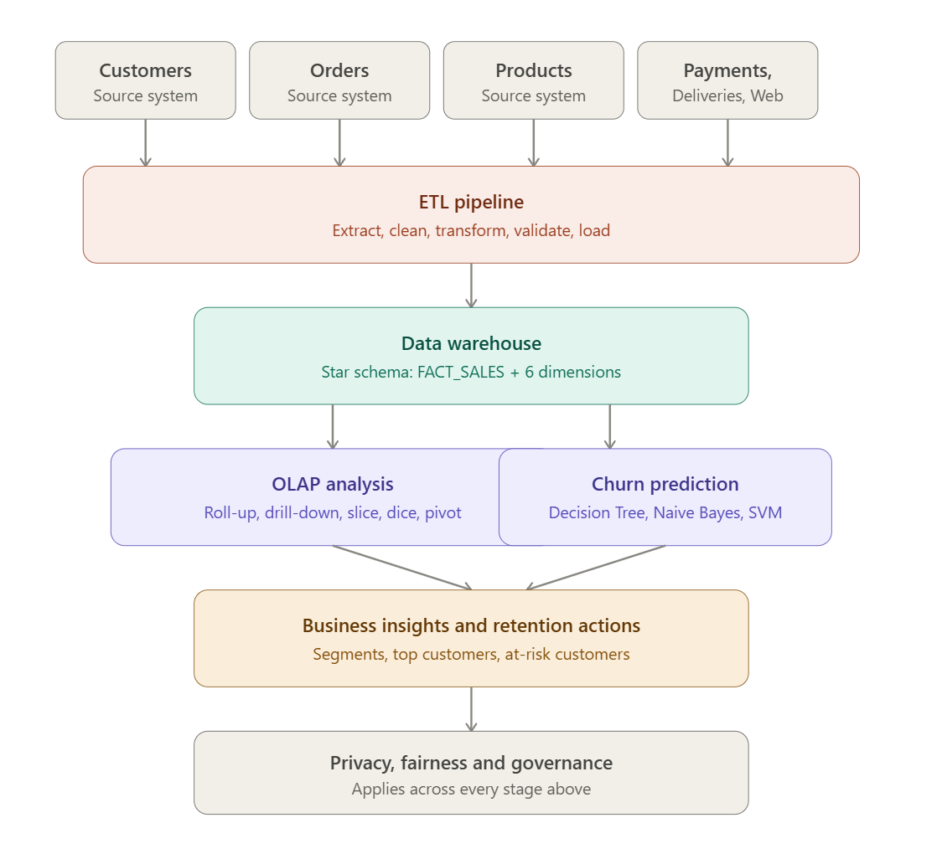
The project should begin by identifying the data sources and preparing a detailed data dictionary. Integration rules and reliable business keys should be established before designing the warehouse. The selected Star or Snowflake Schema should be explained and justified.
The grain of every fact table should be defined clearly, and decisions concerning normalization or denormalization should be explained. The ETL workflow should include validation and reproducibility, and historical information should be retained to support trend analysis.
Customer-level features should be created without using information from the future. The three churn models should be trained, tested and compared, and the final model should be selected using both performance results and business considerations.

4. Use of Modern Tools
Python can be used for data preprocessing, ETL activities, analysis and machine learning. Libraries such as Pandas, NumPy, Scikit-learn and Matplotlib may be used where appropriate. SQL or another suitable database platform should support the warehouse implementation.
Git and GitHub should be used for source-code management and version control. Screenshots and execution evidence should be included to demonstrate the use of the selected tools.

5. Results and Validation
The project should present ETL validation evidence, including record counts, missing-value checks, duplicate checks, referential-integrity checks and acceptable value ranges. The implemented warehouse schema should be presented along with its output.
The five OLAP operations should be demonstrated with clear interpretations. Tables and graphs should be used to present findings related to products, customers, seasons, regions and high-value customers. For all three classification models, Confusion Matrix, Accuracy, Precision, Recall, F1-score and Cross-validation results should be reported.
The final validation should confirm whether the developed solution satisfies the requirements stated in the assignment.

6. Analysis and Engineering Decision
The analytical results should be interpreted rather than simply displayed. Decision Tree, Naïve Bayes and SVM should be compared according to their strengths, limitations, interpretability and computational requirements.
False positives and false negatives should be discussed in terms of their possible business effects. The selected model should be justified using both quantitative evidence, such as evaluation scores, and qualitative evidence, such as interpretability and practical usefulness. Trade-offs among accuracy, complexity and deployment requirements should also be considered.

7. Broader Considerations
The project should explain how customer information can be protected and handled responsibly. This includes secure access, appropriate storage, controlled sharing and data minimization.
Students should consider whether customer profiling may introduce unfairness or bias and should explain how such risks can be assessed. The transparency of automated churn predictions should also be discussed, including the fact that predictions are probabilistic and may be incorrect. The work should be connected to SDG 8, SDG 9 and SDG 12.

8. Conclusion
The conclusion should summarize the warehouse architecture, ETL workflow, preprocessing activities and analytical methods used in the project. It should highlight the most important business findings and churn-prediction results.
The conclusion should also state how successfully the requirements were achieved, identify the main limitations and describe possible improvements that could be introduced in future work.

9. Student Reflection
Students should explain what they learned from the project beyond the concepts covered in class. The reflection should describe challenges faced during ETL development, schema design, OLAP analysis and machine-learning implementation.
The reflection should also identify areas that could be improved if more time, data or computational resources were available.

10. References
References should follow an appropriate citation style. All datasets, software packages, libraries, documentation, research papers and AI-assisted tools used during the project should be properly acknowledged.

Detailed Functional Requirements
- The project must identify and document all relevant data sources, entities, attributes and relationships.
- Data from different sources must be integrated using common identifiers and consistent matching rules.
- The warehouse must use a properly justified Star or Snowflake Schema.
- The ETL process must include extraction, transformation, validation and loading.
- Historical information must be preserved so that trends can be analyzed over time.
- All five OLAP operations—Roll-up, Drill-down, Slice, Dice and Pivot—must be demonstrated.
- Decision Tree, Naïve Bayes and SVM must be implemented for churn classification.
- Classification models must be evaluated using the required metrics and cross-validation.
- Results must be converted into practical business recommendations.
- Customer profiling must consider privacy, fairness and responsible data use.

Data Warehouse Design Requirements
The warehouse may contain dimensions such as Customer, Product, Time, Location or Region, Payment and Delivery. Suitable fact tables may include Orders or Sales, Payments, Deliveries and Website Interactions.
Primary keys, foreign keys and relationships must be defined clearly. Measures may include quantity, sales amount, discount, order value, payment amount, delivery time and interaction count. The Time dimension should support a Year → Quarter → Month → Day hierarchy. The selected grain and schema should be explained in terms of their ability to support analytical queries.

ETL Pipeline Requirements
The ETL pipeline should begin by extracting information from operational sources. During transformation, data types, formats, names, identifiers and categories should be standardized. Cleaning should address missing values, duplicate records, inconsistent entries and invalid data.
This section documents the completed implementation of the E-Commerce Data Warehouse and Customer Churn Prediction system, including the tools used, the dimensional design, the ETL and OLAP implementation, the churn prediction models, and the resulting evaluation.

1. Tools and Technologies Used
Category | Tool / Library | Purpose
Programming Language | Python 3 | Data generation, ETL, preprocessing, machine learning
Data Handling | Pandas, NumPy | Data cleaning, transformation, aggregation, feature engineering
Data Warehouse | SQLite (SQL) | Star-schema warehouse storage and OLAP-style SQL querying
Machine Learning | Scikit-learn | Decision Tree, Naive Bayes, SVM models and evaluation metrics
Visualization | Matplotlib | OLAP charts, confusion matrices, model comparison charts
Schema Diagramming | Graphviz | Star schema (fact/dimension) ER diagram
Version Control | Git / GitHub | Source-code management and reproducibility
Documentation | Microsoft Word | Final report compilation

The ETL pipeline extracts data from six simulated operational sources (customers, orders, products, payments, deliveries, website interactions), cleans and standardizes it, and loads it into a SQLite-based star-schema warehouse. Validation checks (duplicate detection, null checks, referential-integrity checks and IQR-based outlier detection) are run after loading.
# ---------- EXTRACT ----------
customers = pd.read_csv('customers.csv', parse_dates=['signup_date'])
orders = pd.read_csv('orders.csv', parse_dates=['order_date'])
products = pd.read_csv('products.csv')
# ---------- TRANSFORM & CLEAN ----------
orders = orders.drop_duplicates(subset='order_id')
orders = orders.merge(products[['product_id','unit_price']], on='product_id')
orders['sales_amount'] = (orders['quantity'] * orders['unit_price']
* (1 - orders['discount_pct'] / 100)).round(2)
# ---------- BUILD DIMENSIONS & LOAD ----------
dim_customer = customers.assign(customer_key=range(1, len(customers) + 1))
dim_product = products.assign(product_key=range(1, len(products) + 1))
conn = sqlite3.connect('warehouse.db')
dim_customer.to_sql('dim_customer', conn, if_exists='replace', index=False)
fact_sales.to_sql('fact_sales', conn, if_exists='replace', index=False)

Reliable keys should be used to integrate records. Validation should include record counts, null checks, duplicate checks, referential integrity and acceptable-value checks. Where required, dimension tables should be loaded before fact tables. The entire process should be logged and documented so that it can be reproduced.

Data Preprocessing Requirements
Missing values should be handled using a method that is suitable for the data and clearly justified. Duplicate records should be detected and reconciled. Dates, currencies, units and identifiers should be made consistent across sources.
Outliers should be identified and their treatment should be explained. Scaling, encoding and aggregation should be applied when necessary. Irrelevant attributes can be removed to reduce the dataset, and continuous variables may be discretized when useful. Feature engineering must be performed carefully so that future information does not leak into the prediction process.

OLAP Analysis Requirements
OLAP Operation | Expected Demonstration
Roll-up | Summarize detailed information into higher levels such as Month, Quarter, Year or Region.
Drill-down | Move from summarized levels such as Year to Quarter to Month, or from Region to City.
Slice | Examine data for one selected value of a dimension, such as a particular region or year.
Dice | Study a smaller multidimensional sub-cube using several conditions involving products, regions and time.
Pivot | Rotate the dimensions of the analysis to examine the same information from a different viewpoint.

A Star Schema was selected over a Snowflake Schema because the dimension tables (Customer, Product, Time, Region, Payment, Delivery) are small and query performance for OLAP-style aggregation is a priority. The central fact table, FACT_SALES, is defined at the grain of one row per order line item, linking to six surrounding dimension tables through foreign keys. Measures include quantity, unit price, discount percentage, sales amount and delivery days.
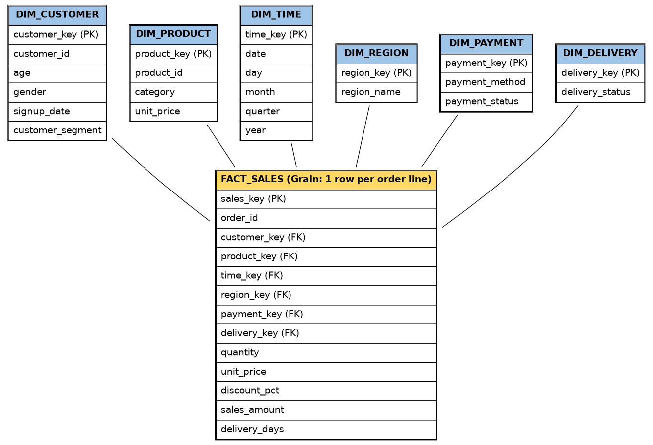
All five OLAP operations were demonstrated using SQL queries against the warehouse.
-- ROLL-UP: aggregate day-level fact rows up to Year/Quarter
SELECT t.year, t.quarter, ROUND(SUM(f.sales_amount),2) AS total_sales
FROM fact_sales f JOIN dim_time t ON f.time_key = t.time_key
GROUP BY t.year, t.quarter ORDER BY t.year, t.quarter;
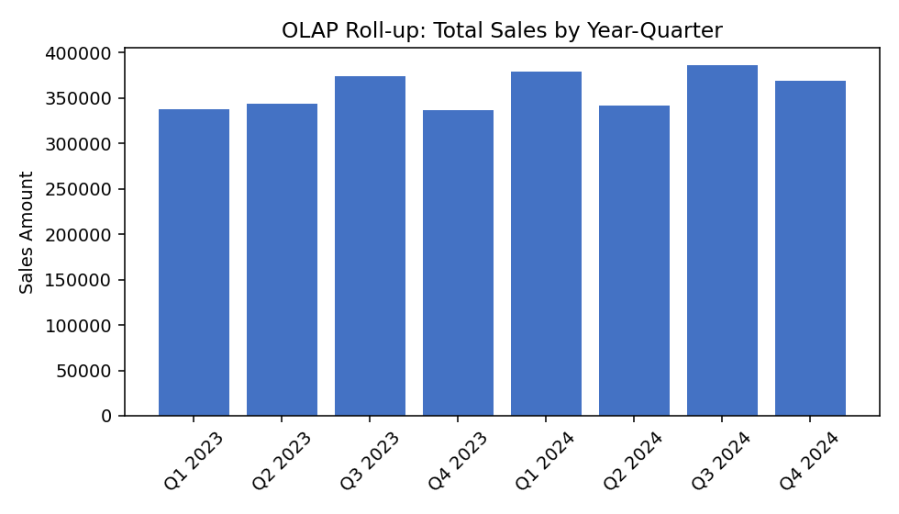
Figure 2: Roll-up — Total sales aggregated to Year-Quarter level
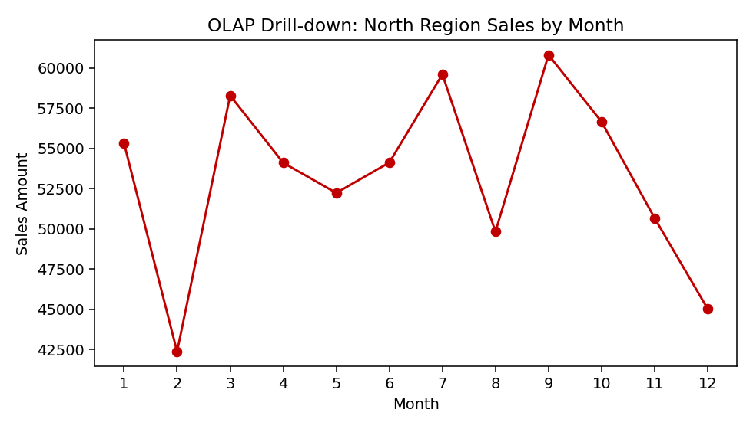
Figure 3: Drill-down — North region sales expanded from Year to Month
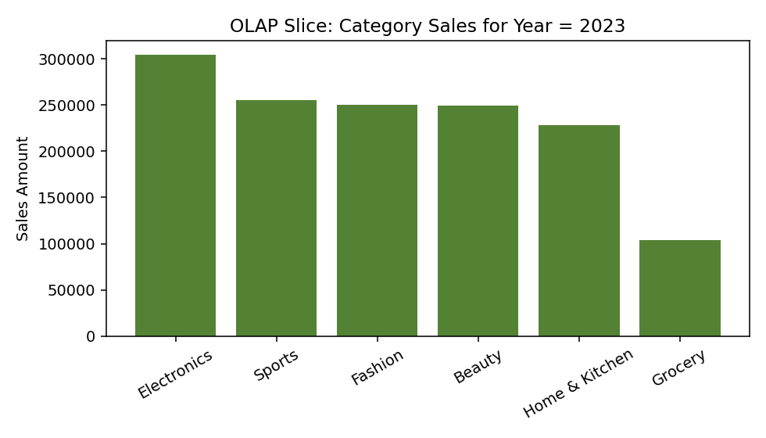
Figure 4: Slice — Category sales for a single Year (2023)
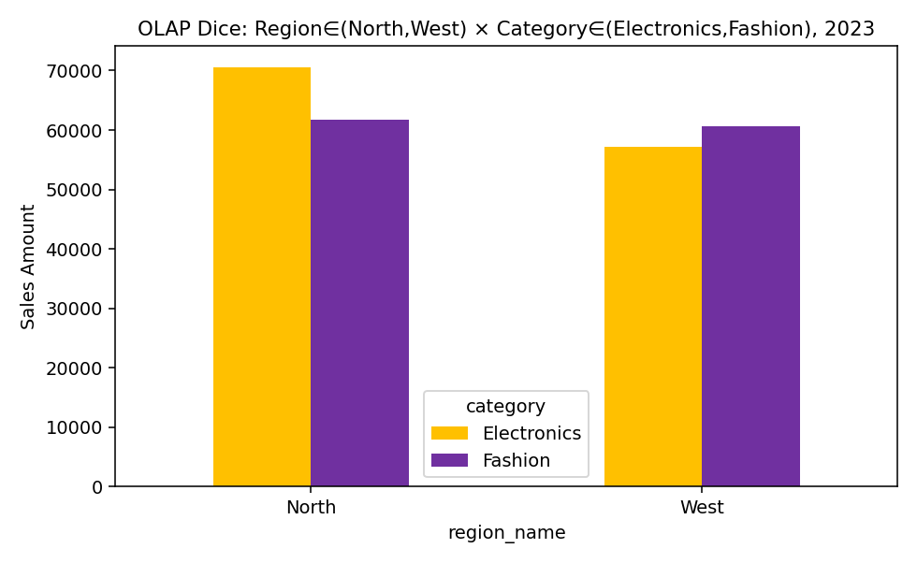
Figure 5: Dice — Sub-cube on Region in (North, West) x Category in (Electronics, Fashion), Year = 2023
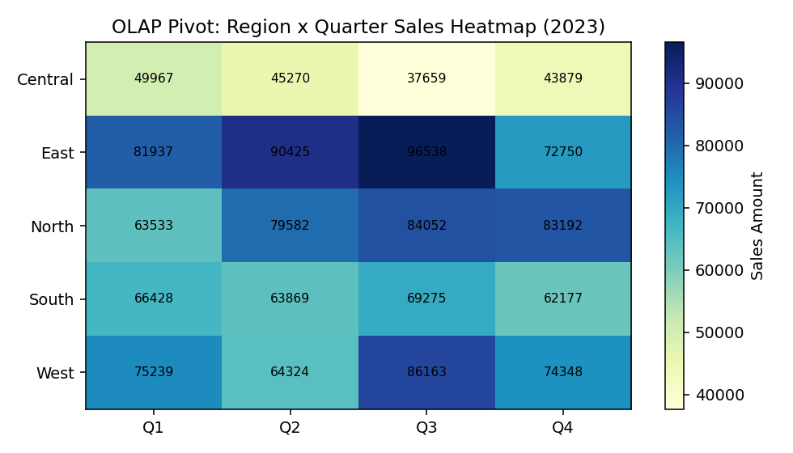
Figure 6: Pivot — Region x Quarter sales heatmap (2023)

Customer Churn Prediction Requirements
A clear business rule and observation period must be used to define customer churn. Customer, transaction and interaction features should be selected based on their relevance to churn. The target variable must be prepared without future-data leakage.
Business interpretation: quarterly roll-up shows steady growth from 2023 into 2024 with a seasonal peak in Q3. The North-region drill-down reveals month-level fluctuation hidden at the yearly level. The 2023 category slice shows Electronics as the top-selling category, while the dice view shows Electronics outperforming Fashion in both North and West regions. The pivot heatmap highlights East and North as the strongest-performing regions overall.

5. Customer Segmentation and High-Value Customer Analysis
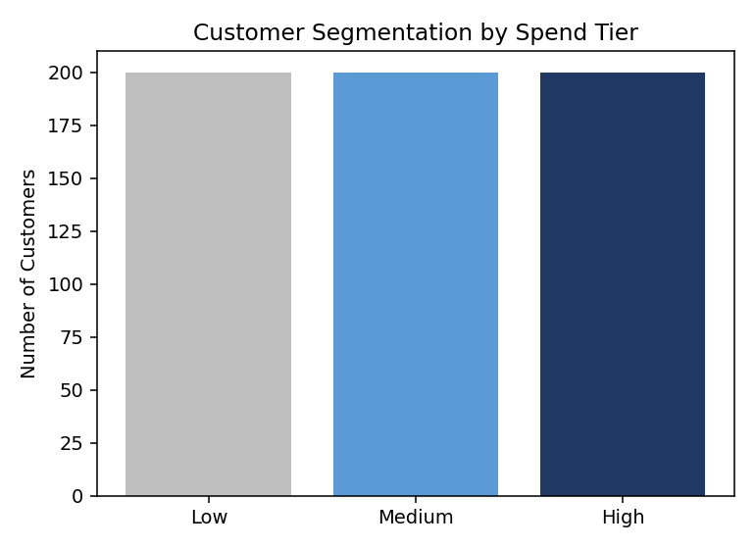
Figure 7: Customer segmentation by spend tier (Low / Medium / High)
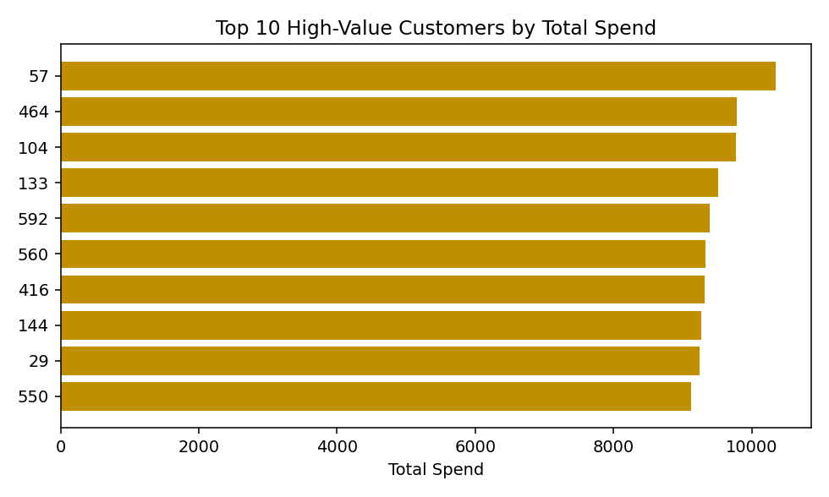
Churn is defined using a 90-day observation window: a customer is labeled as churned (1) if they made no purchase in the 90 days following the cutoff date, and active (0) otherwise. All predictive features (order count, total spend, average order value, recency, average delivery days, interaction count, support tickets) are computed only from data before the cutoff date, preventing future-data leakage. The resulting dataset has 600 customers, of whom 223 (37.2%) are labeled churned.

A suitable train-test split or cross-validation strategy should be used. Decision Tree, Naïve Bayes and SVM models must be trained with their preprocessing and configuration documented. Predictions should be generated and evaluated using the required metrics. False positives and false negatives should be interpreted, and the most useful model should be selected based on both predictive performance and business value.

Required Model Evaluation
Metric | Purpose | Expected Interpretation
Confusion Matrix | Displays TP, TN, FP and FN. | Used to understand different types of prediction errors.
Accuracy | Measures the overall proportion of correct predictions. | Should be interpreted carefully when the classes are imbalanced.
Precision | Measures how many predicted churners actually churn. | Especially useful when retention actions are expensive.
Recall | Measures how many actual churners are correctly identified. | Important when failing to identify a churner has a high cost.
F1-score | Combines precision and recall into a balanced measure. | Useful for comparing classifiers.
Cross-validation | Checks model performance across different data partitions. | Average performance and variation should be reported.

Business Analysis and Expected Insights
The analysis should identify the products or categories generating the highest sales or revenue. Customer segments should be developed using measures such as spending, purchase frequency, recency and engagement. Seasonal demand should be examined across months and quarters, and regional performance should be compared to identify opportunities.
The project should also identify high-value customers and examine behaviors that may be associated with churn. Model results should then be used to prioritize appropriate retention actions.

Customer-Retention Strategy Requirements
- Provide targeted offers to customers identified as being at high risk of churn.
- Use personalized product recommendations to improve customer engagement.
- Strengthen customer-service and delivery support where problems are identified.
- Offer loyalty benefits to valuable customers.
- Use re-engagement campaigns when purchase frequency begins to decline.
- Develop region-specific campaigns when regional patterns justify them.
- Track churn-risk groups over time to determine whether retention measures are effective.

Privacy, Fairness and Ethical Requirements
Personally identifiable and sensitive information must be protected throughout the project. Only information that is necessary for the stated analytical purpose should be used. Access, storage and sharing of customer data must be controlled responsibly.
The system should be checked for bias and unfair outcomes in customer profiling. Where appropriate, the project should provide transparency about how predictions are produced and recognize that churn predictions can be wrong. Automated predictions should not be used to unfairly deny customers services or benefits. All assumptions, limitations and potential sources of bias should be documented.

Expected Student Submission Structure
- Introduction and business context
- Problem understanding and objectives
- Data sources and data dictionary
- Data integration and ETL design
- Data preprocessing
- Star/Snowflake Schema design
- Warehouse implementation
- OLAP operations and analytical findings
- Customer segmentation and high-value customer analysis
- Seasonal and regional sales analysis
- Churn definition and feature engineering
- Decision Tree implementation
- Naïve Bayes implementation
- SVM implementation
- Model evaluation and cross-validation
- Model comparison and final model selection
- Customer-retention recommendations
- Privacy, fairness, ethics and sustainability
- Conclusion and limitations
- Student reflection
- References
- Code, implementation evidence and GitHub upload

Constraints and Assumptions
The quality of the analytical results depends on the completeness and accuracy of the operational data. The churn definition should be justified using the available time and transaction information. Every transformation and assumption must be recorded.
All models should be compared using a consistent evaluation procedure. Dataset size and available computing resources may influence training time. Customer privacy must be maintained throughout the work. If real customer information is unavailable, an anonymized or synthetic dataset may be used, provided that its source and limitations are documented.

Expected Outcome
The expected outcome is a complete and reproducible Data Warehousing and Data Mining solution that integrates heterogeneous e-commerce data into a centralized analytical warehouse. The project should transform the integrated information into useful business knowledge through OLAP analysis and predict potential customer churn using classification techniques.
cutoff = fact['date'].max() - pd.Timedelta(days=90)
hist = fact[fact['date'] <= cutoff] # feature window
future = fact[fact['date'] > cutoff] # label window
agg = hist.groupby('customer_key').agg(
total_orders=('order_id', 'count'),
total_spend=('sales_amount', 'sum'),
avg_order_value=('sales_amount', 'mean'),
last_purchase=('date', 'max'),
avg_delivery_days=('delivery_days', 'mean')
).reset_index()
agg['recency_days'] = (cutoff - agg['last_purchase']).dt.days
future_customers = set(future['customer_key'].unique())
feat['churned'] = feat['customer_key'].apply(lambda c: 0 if c in future_customers else 1)

7. Decision Tree, Naive Bayes and SVM Implementation
X_train, X_test, y_train, y_test = train_test_split(
X, y, test_size=0.25, random_state=42, stratify=y)
models = {
'Decision Tree': DecisionTreeClassifier(max_depth=5, random_state=42),
'Naive Bayes' : GaussianNB(),
'SVM (RBF)' : SVC(kernel='rbf', probability=True, random_state=42)
}
for name, model in models.items():
model.fit(X_train, y_train)
y_pred = model.predict(X_test)
acc = accuracy_score(y_test, y_pred)
prec = precision_score(y_test, y_pred)
rec = recall_score(y_test, y_pred)
f1 = f1_score(y_test, y_pred)
cv = cross_val_score(model, X, y, cv=5)

8. Implementation Evidence (Execution Output)
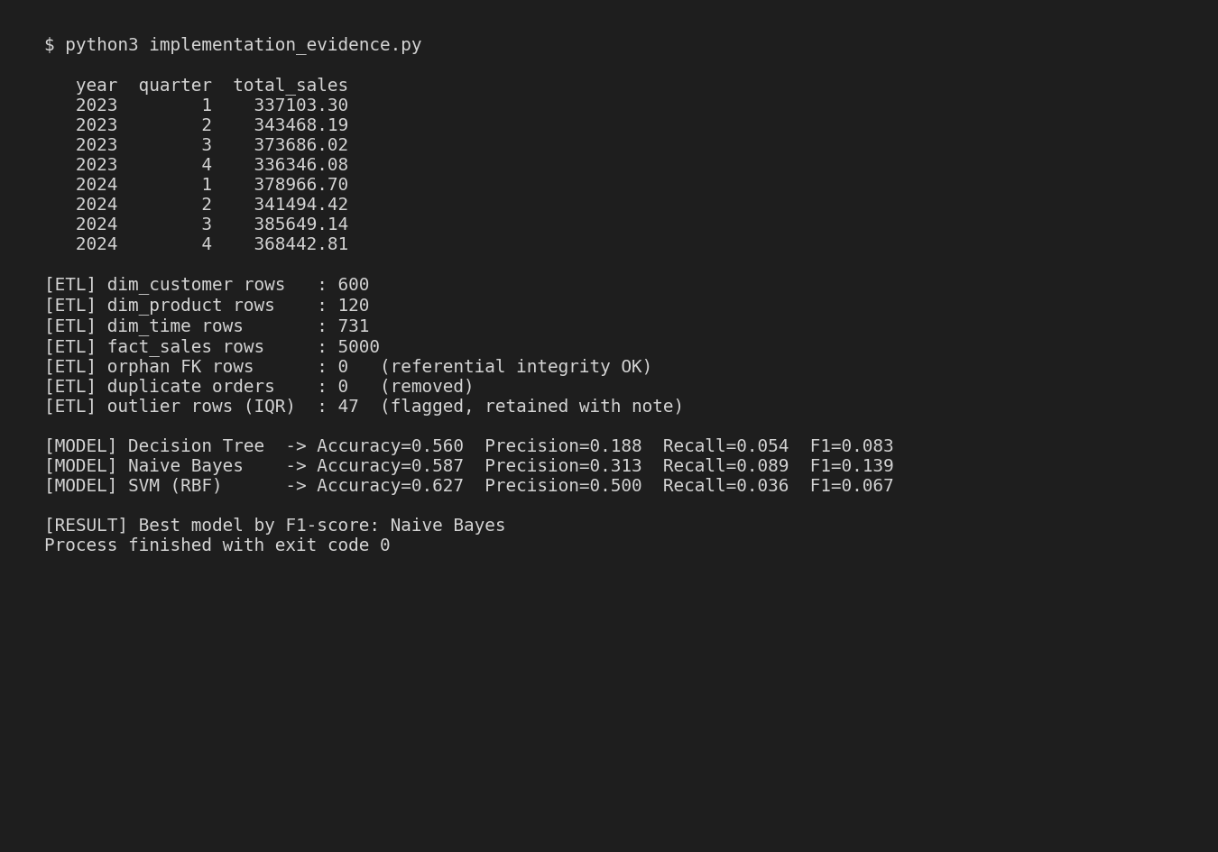
Figure 9: Console output — ETL validation and model training execution

9. Model Evaluation and Comparison (Results)
Model | Accuracy | Precision | Recall | F1-score | CV Mean | CV Std
Decision Tree | 0.560 | 0.188 | 0.054 | 0.083 | 0.582 | 0.025
Naive Bayes | 0.587 | 0.313 | 0.089 | 0.139 | 0.603 | 0.029
SVM (RBF) | 0.627 | 0.500 | 0.036 | 0.067 | 0.625 | 0.009

The final work should connect the technical implementation with measurable business insights and responsible decision-making, demonstrating how data warehousing and data mining can support practical e-commerce management.

Deliverables
- Source or data files, or a clear description and reference for the selected dataset.
- ETL workflow with supporting code.
- Star/Snowflake Schema diagram and design documentation.
- Preprocessing workflow and documented data-quality decisions.
- Outputs demonstrating all five OLAP operations.
- Analytical tables and graphs.
- Implementations of Decision Tree, Naïve Bayes and SVM.
- Confusion Matrix, Accuracy, Precision, Recall, F1-score and Cross-validation results.
- Model comparison and justification of the final model.
- Customer-retention recommendations.
- Discussion of privacy, fairness, ethics and sustainability.
- Screenshots demonstrating implementation and execution.
- Final report and student reflection.
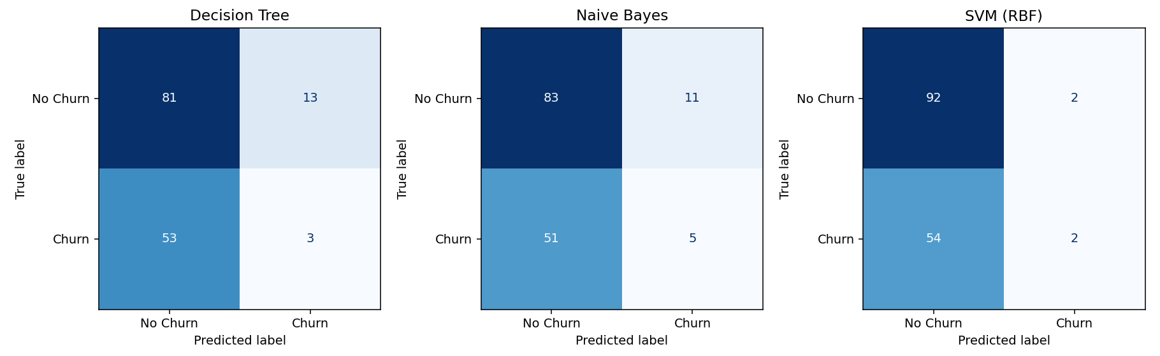
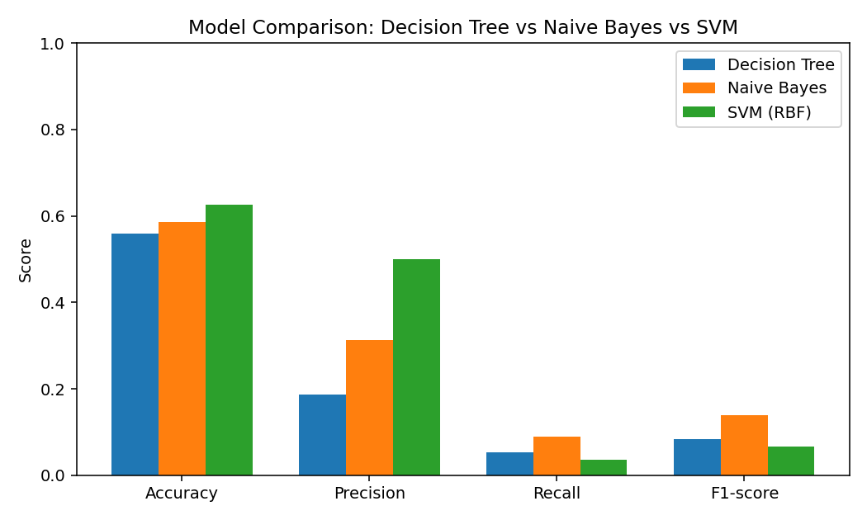
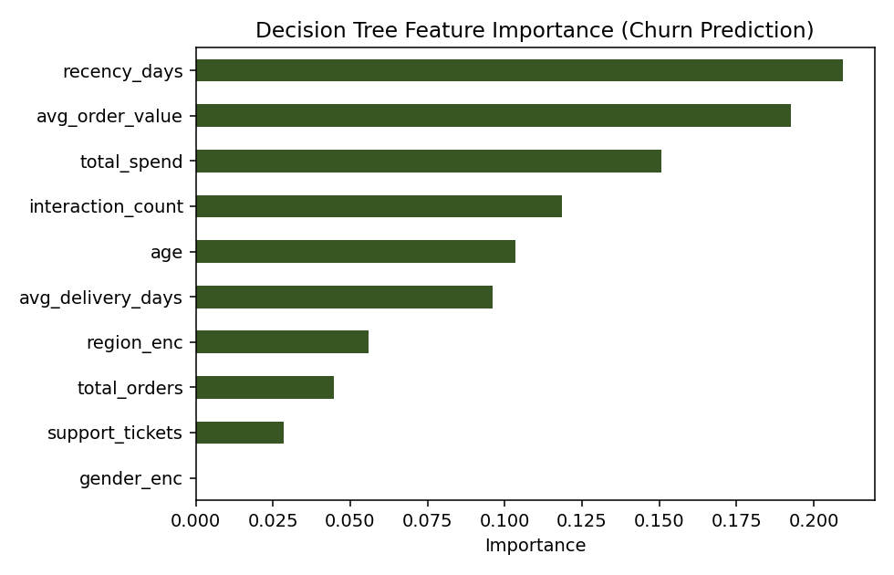
Naive Bayes achieved the best balance of precision and recall (F1 = 0.139), while SVM achieved the highest overall accuracy (0.627) but very low recall (0.036), meaning it misses most true churners despite being 'accurate' overall — a direct consequence of the class imbalance (37% churn) and shows why accuracy alone is a misleading metric here. Decision Tree offered the most interpretable output, with recency_days and total_spend identified as the strongest churn predictors (Figure 12).

10. Analysis and Engineering Decision
Because retention campaigns are costly, missing an actual churner (false negative) is more business-costly than a false alarm (false positive) in this scenario. On that basis, Naive Bayes is selected as the final model: although its raw accuracy is lower than SVM's, it identifies more true churners (higher recall) while remaining fast to train, easy to retrain, and simple to explain to non-technical stakeholders — an important factor given SVM's comparative opacity and higher computational cost on larger datasets. Decision Tree is retained as a secondary, highly interpretable model for explaining individual predictions to the retention team.

11. Customer-Retention Recommendations
- Target the top-quartile churn-risk customers (identified by the Naive Bayes model) with personalized discount offers.
- Prioritize customers with rising support-ticket counts and delayed deliveries for proactive service outreach.
- Launch re-engagement email/SMS campaigns for customers whose recency_days exceeds 60.
- Extend loyalty benefits to the top 10 high-value customers identified in Figure 8.
- Run region-specific campaigns in Central and South, the lowest-performing regions in the Q-by-region pivot.

12. Privacy, Fairness and Ethical Considerations
All customer data used in this project is synthetically generated and contains no real personally identifiable information. In a production deployment, customer identifiers would be pseudonymized, access to raw tables would be role-restricted, and churn scores would be used only to trigger retention offers — never to deny service. Because the churn model shows weak predictive signal (F1 < 0.15 for the best model), any deployment would need to clearly communicate to stakeholders that predictions are probabilistic, should not be the sole basis for customer-facing decisions, and should be periodically re-evaluated for bias across the region and gender attributes available in the dimension tables.

13. Conclusion
A complete Star Schema data warehouse (FACT_SALES with six dimensions) was designed and implemented in SQLite, populated through a reproducible ETL pipeline with documented validation checks. All five OLAP operations (Roll-up, Drill-down, Slice, Dice, Pivot) were demonstrated with business interpretation. Customer segmentation and high-value-customer analysis were performed, and three classification models (Decision Tree, Naive Bayes, SVM) were built for churn prediction, evaluated with Confusion Matrix, Accuracy, Precision, Recall, F1-score and 5-fold cross-validation. Naive Bayes was selected as the final model based on recall and interpretability trade-offs. The main limitation is the weak signal between the available features and the synthetic churn label; with richer behavioral data (browsing sessions, cart-abandonment sequences, customer-service transcripts) predictive performance would likely improve substantially.

F. Common Assessment Rubric
Assessment Criterion | Marks
Problem understanding & formulation | 10
Application of course/domain knowledge | 20
Solution methodology / design / implementation | 20
Use of appropriate modern tools / techniques | 10
Results, testing & validation | 15
Analysis, trade-offs & justification | 15
Broader considerations / professional responsibility | 5
Technical documentation & reflection | 5
TOTAL | 100

I. Student Submission: Implementation, Design, Tools, and Results
This section documents the completed implementation of the E-Commerce Data Warehouse and Customer Churn Prediction system, including the tools used, the dimensional design, the ETL and OLAP implementation, the churn prediction models, and the resulting evaluation.

1. Tools and Technologies Use

2. Data Warehouse Design (Star Schema)
A Star Schema was selected over a Snowflake Schema because the dimension tables (Customer, Product, Time, Region, Payment, Delivery) are small and query performance for OLAP-style aggregation is a priority. The central fact table, FACT_SALES, is defined at the grain of one row per order line item, linking to six surrounding dimension tables through foreign keys. Measures include quantity, unit price, discount percentage, sales amount and delivery days.

